Angular - Navigation
Navigation in web applications refers to the process of moving (navigating) through different pages or views within an application. It allows users to interact with various components, access different sections, and use application features.

Let's consider a simple login page in an application. On this login page, users can see links for Sign Up and Forgot Password. These links allow users to navigate to the Sign-Up and Forgot Password sections or components.

Navigation in Angular
In Angular, navigation is a feature that allows users to move between different sections or components within an application. This can be done by defining routing for an individual click requests without using the routerLink directive from the RouterModule.

In this lab, we will discuss how to manually set the navigation without using the routerLink directive. In Angular, the router service provides the navigate() method to programmatically navigate to different routes within the application.

Example - Setting Navigation Manually
To manually set navigation and navigate through different components in Angular, follow these steps:
- Create a new application app-navigate. Open with VS Code.
- Create product component
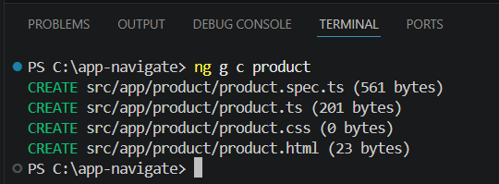
- Create inventory component.
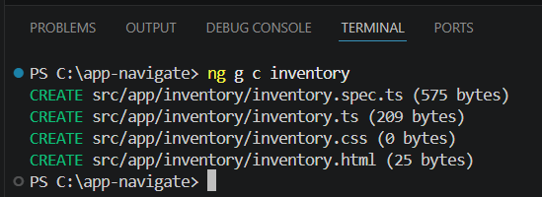
- Open the app.ts file and prepare the code:
import { CommonModule } from '@angular/common';
import { Component, signal } from '@angular/core';
import { Router, RouterModule, RouterOutlet } from '@angular/router';

@Component({
selector: 'app-root',
imports: [RouterOutlet, CommonModule, RouterModule],
templateUrl: './app.html',
styleUrl: './app.css'
})
export class App {
protected readonly title = signal('myApp');
constructor(private router: Router){}

open(data: any){
if(data === "product"){
//here used navigate() to set navigation manually
this.router.navigate(["/product"]);
}
else if(data === "inventory"){
this.router.navigate(["/inventory"]);
}
}
}
- Open the app.html file and prepare the code:
<h1>Welcome to Angular Application</h1>
<button (click)="open('product')">Go to Product</button>
<button (click)="open('inventory')">Go to Inventory</button>
<router-outlet/>
- Open the app.routes.ts file and place the below code:
import { Routes } from '@angular/router';
import { Product } from './product/product';
import { Inventory } from './inventory/inventory';

export const routes: Routes = [
{path: 'product', component: Product},
{path: 'inventory', component: Inventory}
];
- Save all files.
- Now run the application
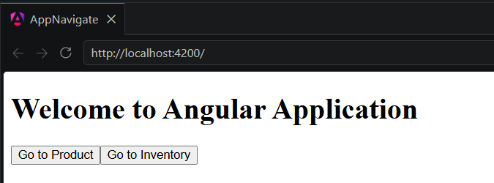
Try click the buttons

